Chapter 2 (Bluman)
Frequency Distributions and Graphs
Data Representation
Data presentation is the method of organizing, summarizing, and showing information using tools such as tables, charts, diagrams, histograms, and graphs.
Objectives of Data Presentation
- Simplify raw data: Makes large amounts of raw data easier to understand and analyze.
- Remove complexity: Removes unnecessary details and highlights the important features of the data.
- Make comparison easier: Helps us compare different sets or groups of data and draw conclusions.
- Help in statistical analysis: Divides data into similar groups so we can easily identify similarities and differences.
Frequency Distribution
Frequency distribution is a table that organizes a data set into a suitable number of classes or groups and shows the frequency of each class.
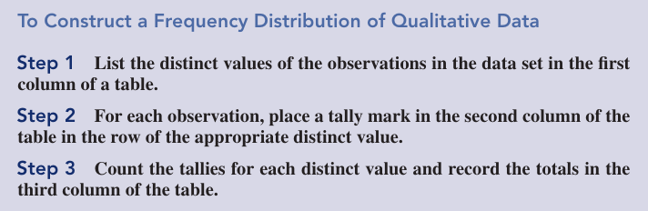

Types of Frequency Distribution
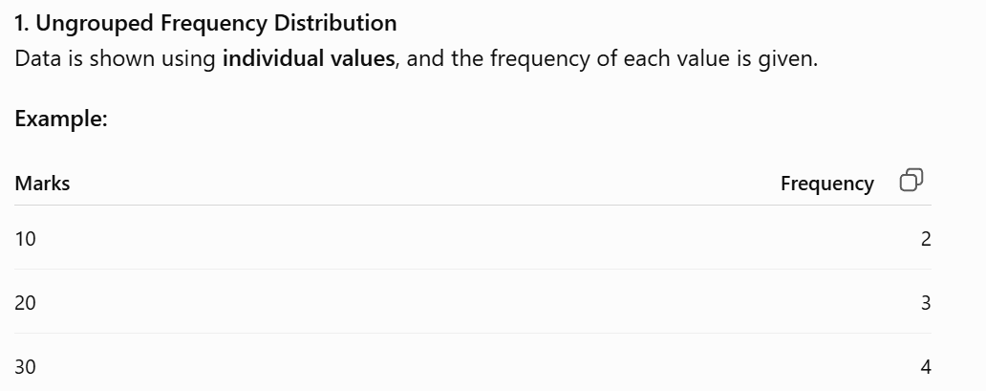
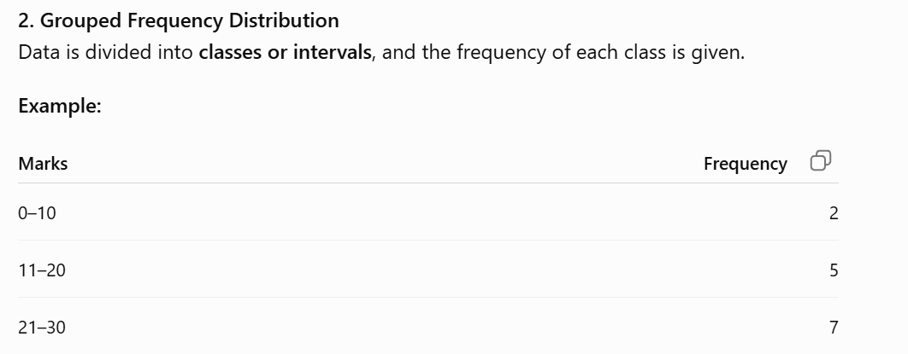
3. Percentage Frequency
Percentage frequency shows the frequency of a value or class as a percentage of the total frequency.
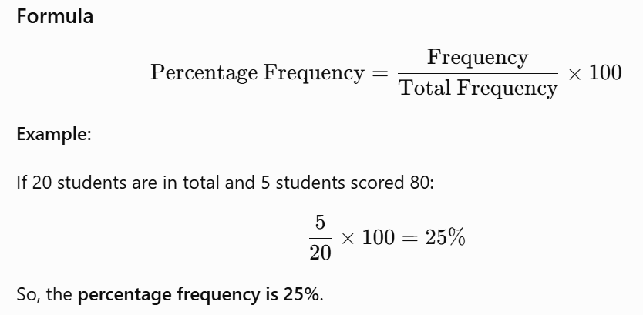
4. Cumulative Frequency Distribution
Cumulative frequency distribution is a table that shows the running total of frequencies up to each class.
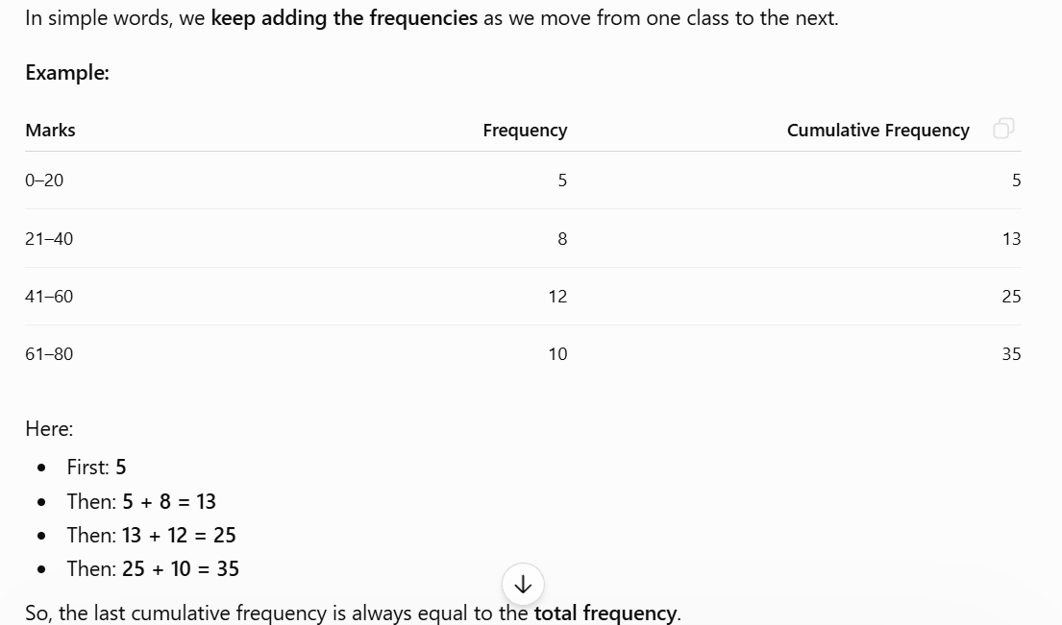

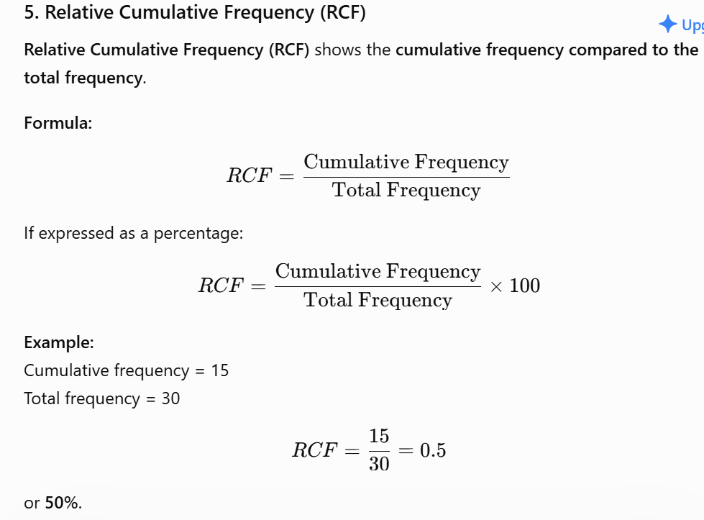

Example
